**FitFood,**

**An Online food delivery**

**Admin Dashboard Testing**

Table of Contents

Test 1: Logging In 3

• Process 1: Logging in with invalid details 3

• Process 2: Logging in with valid user details 4

Test 2: Viewing ‘details’ from the side menu 5

• Process 1: Clicking the ‘Orders’ option from the side menu 5

• Process 2: Clicking the ‘Category’ option from the side menu 6

• Process 3: Clicking the ‘Menu’ option from the side menu 7

Test 3: Add, update and delete for Categories 8

Test 4 : Add, update and delete for Menu 11

Test 11: Logging Out 13

• Process: Clicking the ‘Logout’ button 13

# Test 1: Logging In

## Process 1: Logging in with invalid details

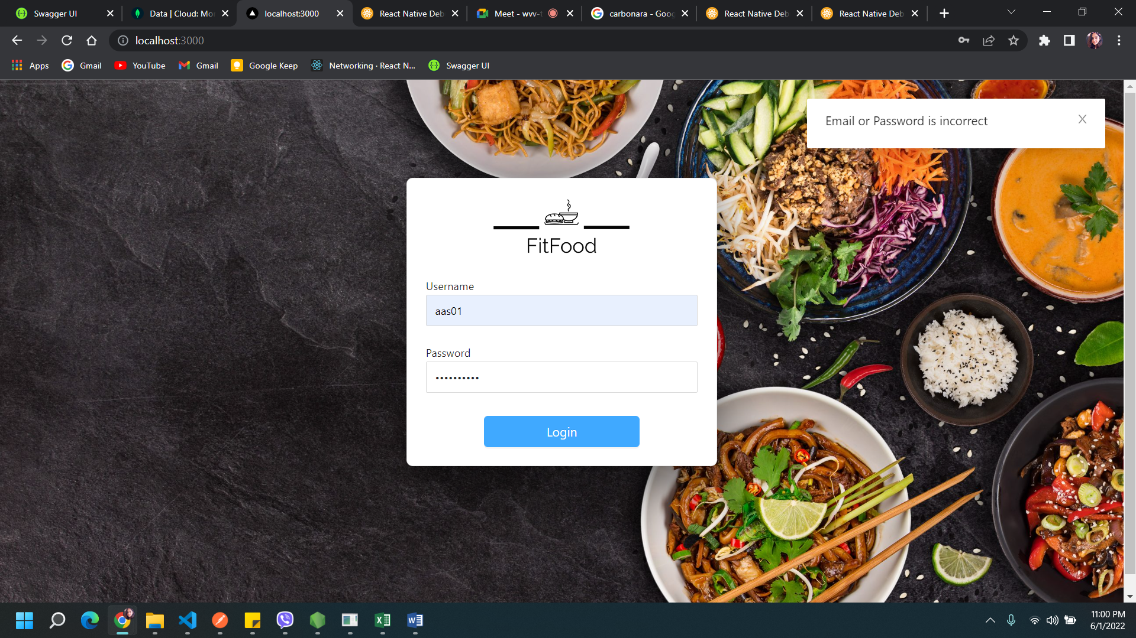

**Outcome:** An error message saying “Incorrect Email or Password” is displayed.

## Process 2: Logging in with valid user details

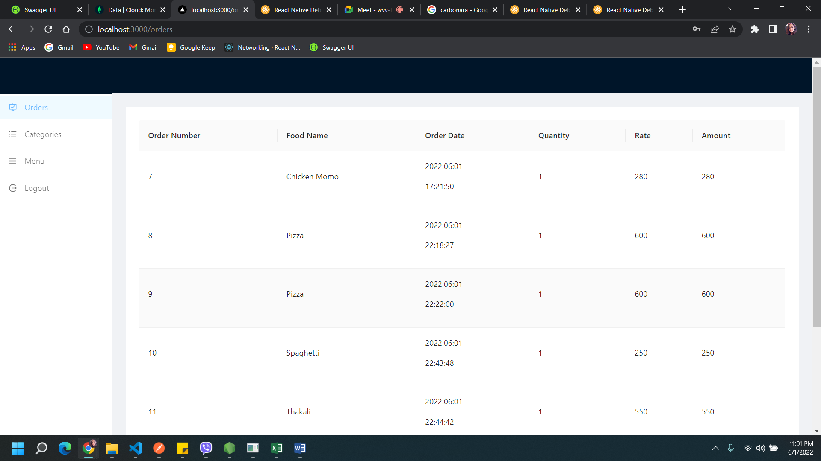

**Outcome:** Login is successful and the admin dashboard appears.

# Test 2: Viewing ‘details’ from the side menu

## Process 1: Clicking the ‘Orders’ option from the side menu

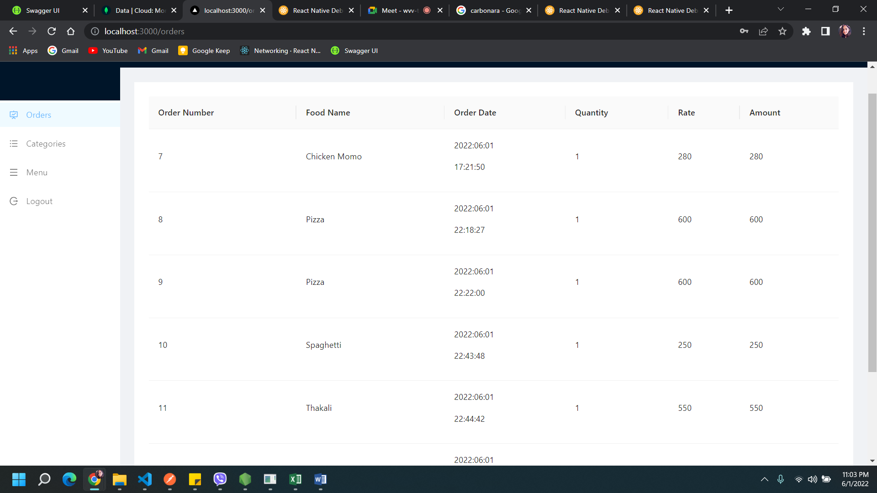

**Outcome:** The details about the order is displayed.

## Process 2: Clicking the ‘Category’ option from the side menu

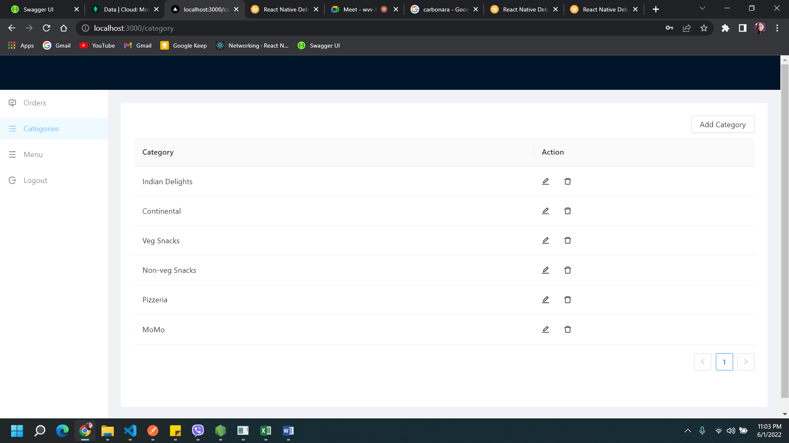

**Outcome:** The list of categories is displayed.

## Process 3: Clicking the ‘Menu’ option from the side menu

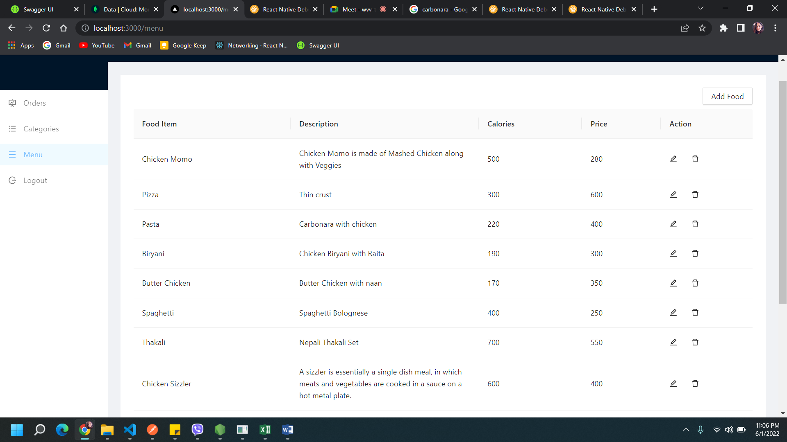

**Outcome:** The details about the menu items are displayed.

# Test 3: Add, update and delete for Categories

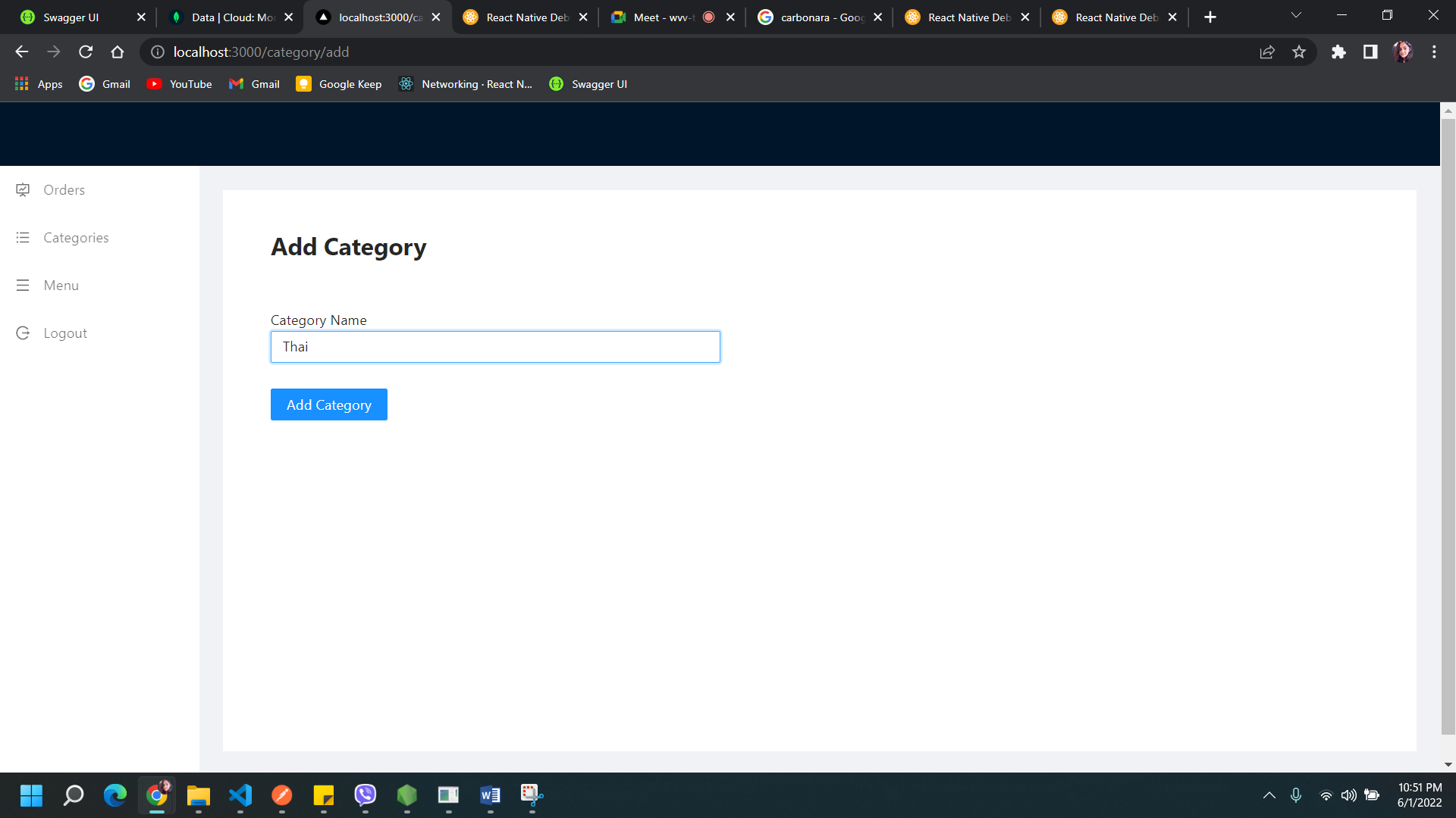

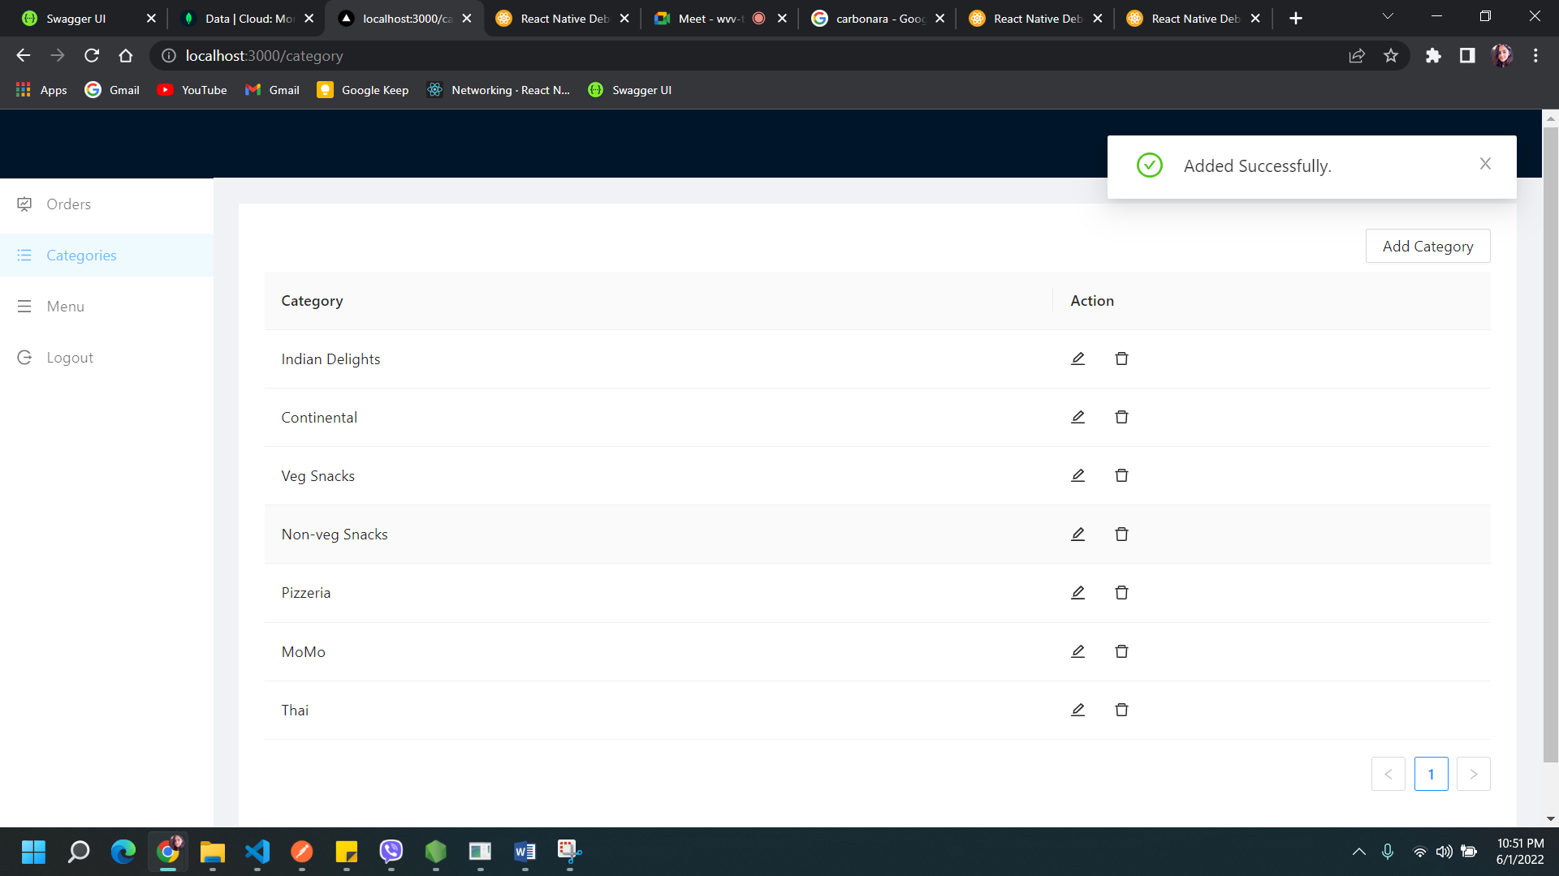

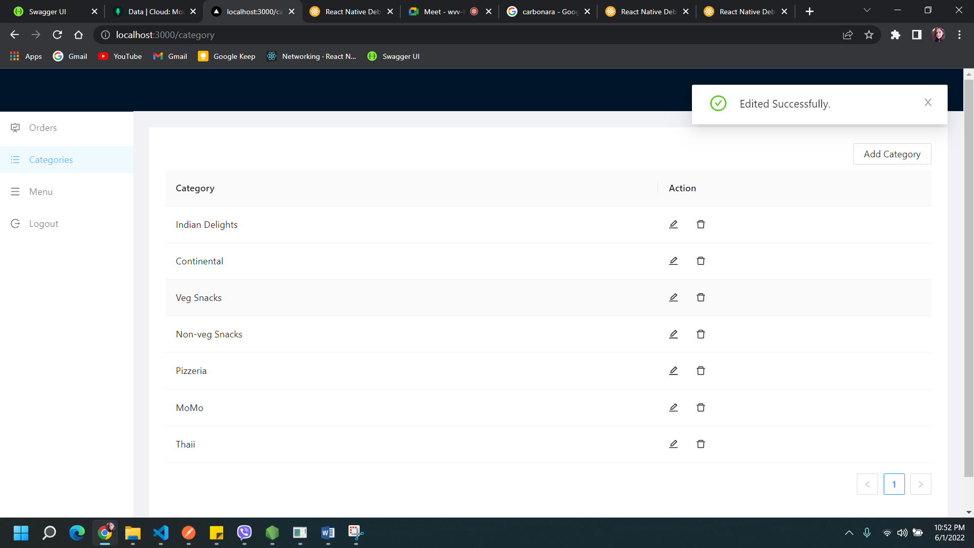

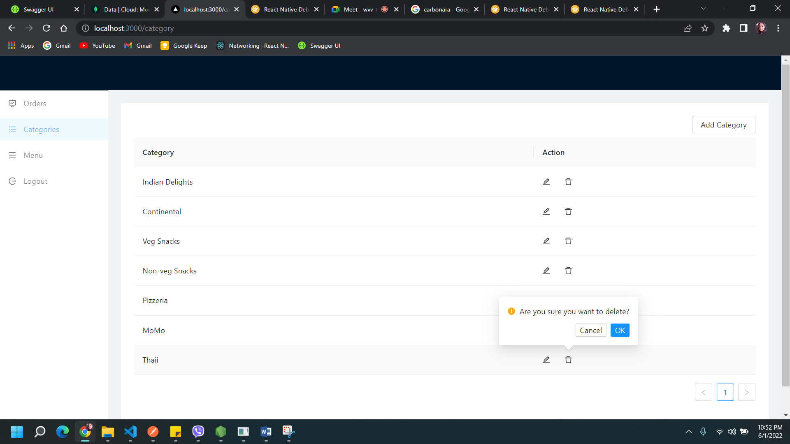

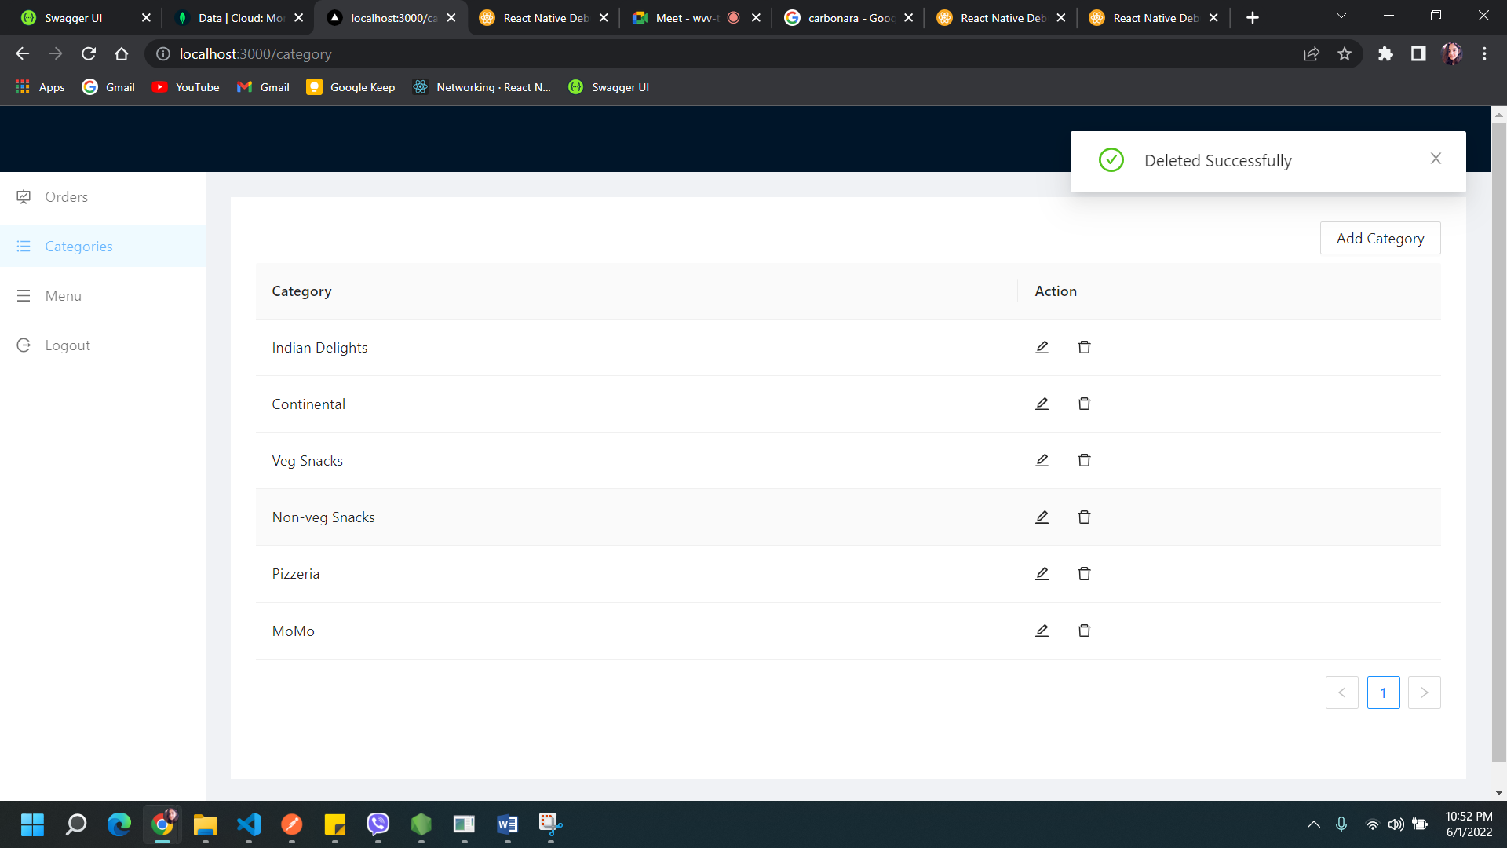

**Outcome:** The categories are added, updated and deleted.

# Test 4 : Add, update and delete for Menu

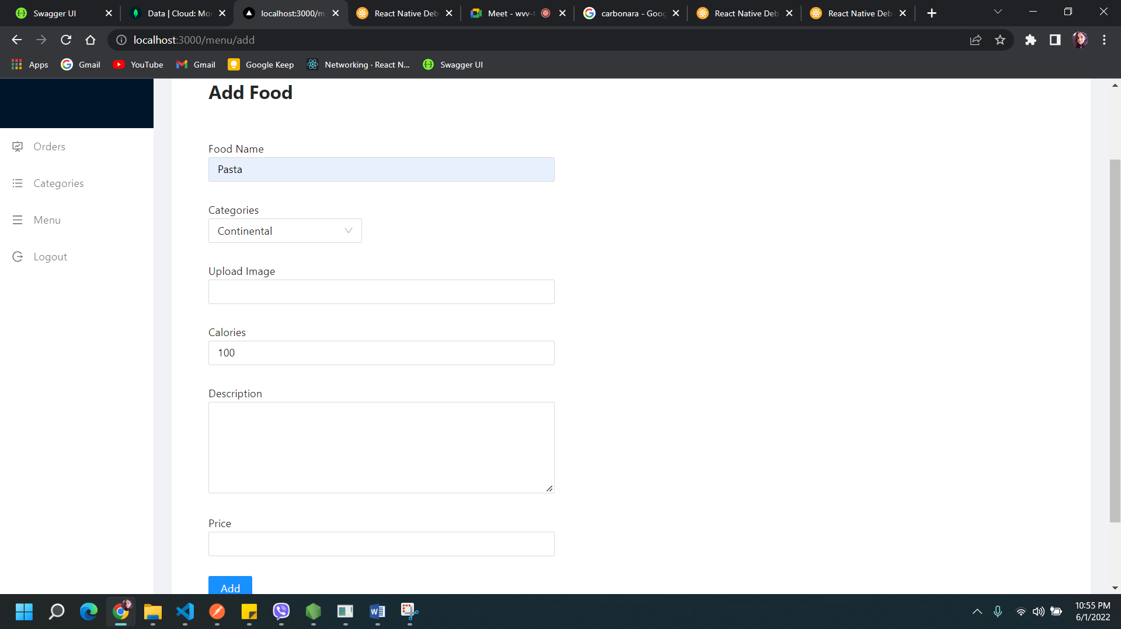

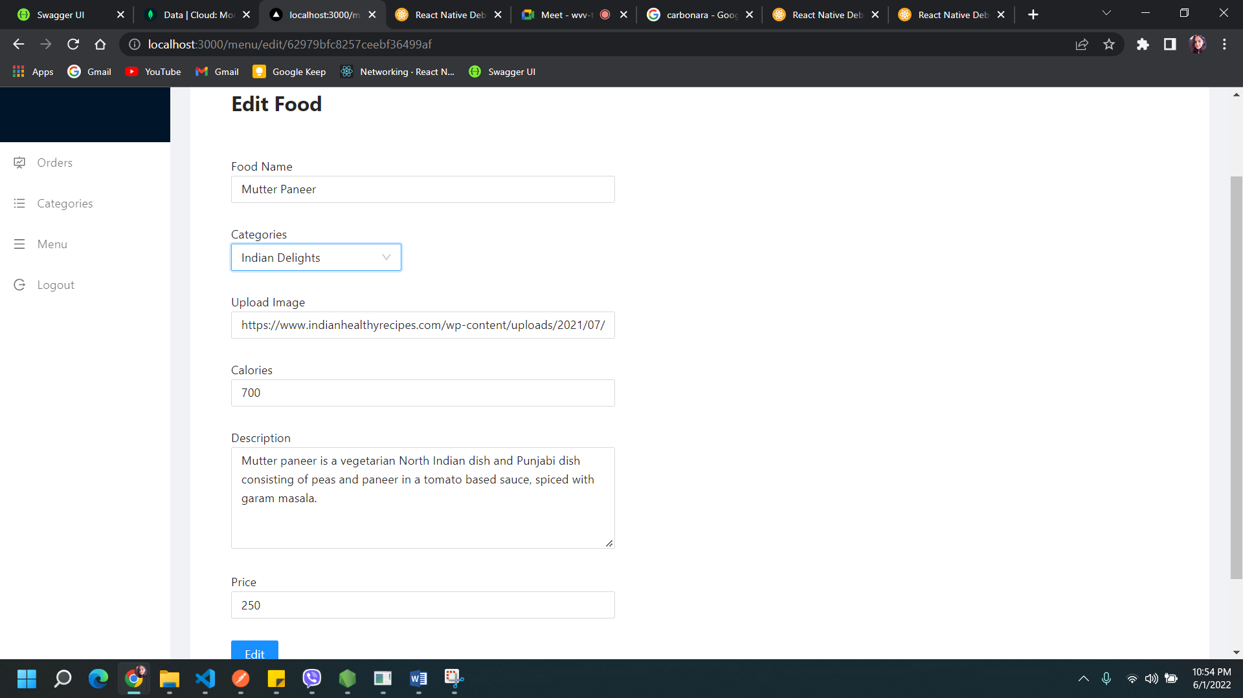

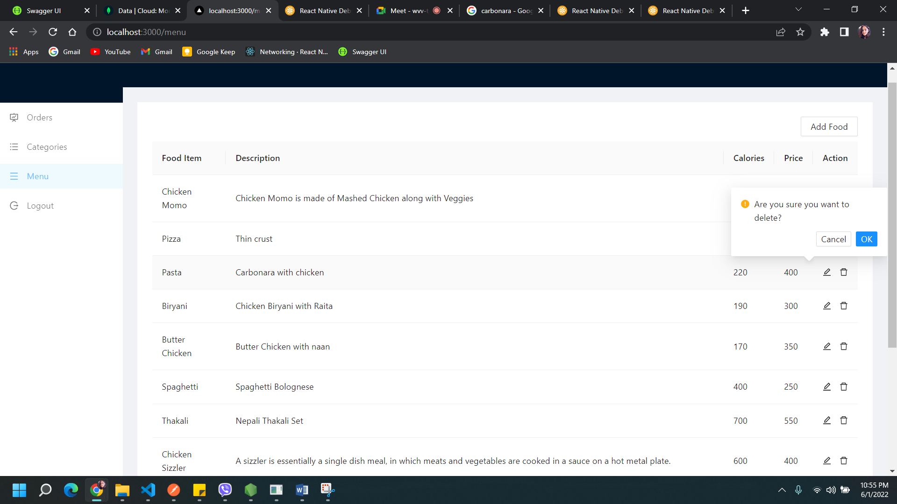

**Outcome:** The menu items are added, updated and deleted.

# Test 11: Logging Out

## Process: Clicking the ‘Logout’ button

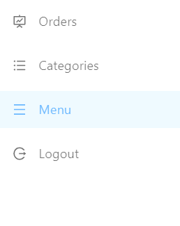

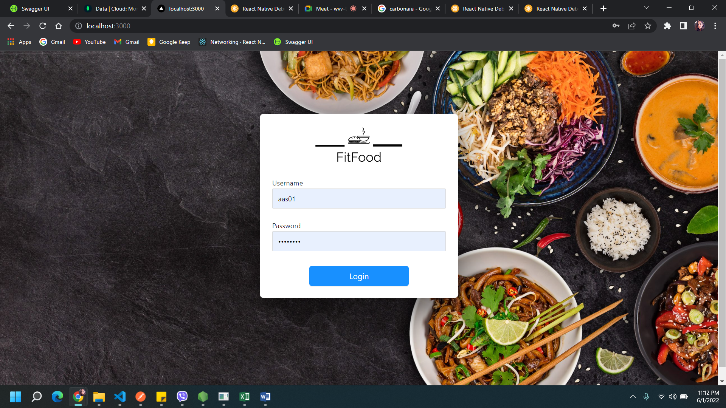

**Outcome:** The user is logged out and redirected to login form page.